Installation - FastApi
- Clone or download the code on the git hub
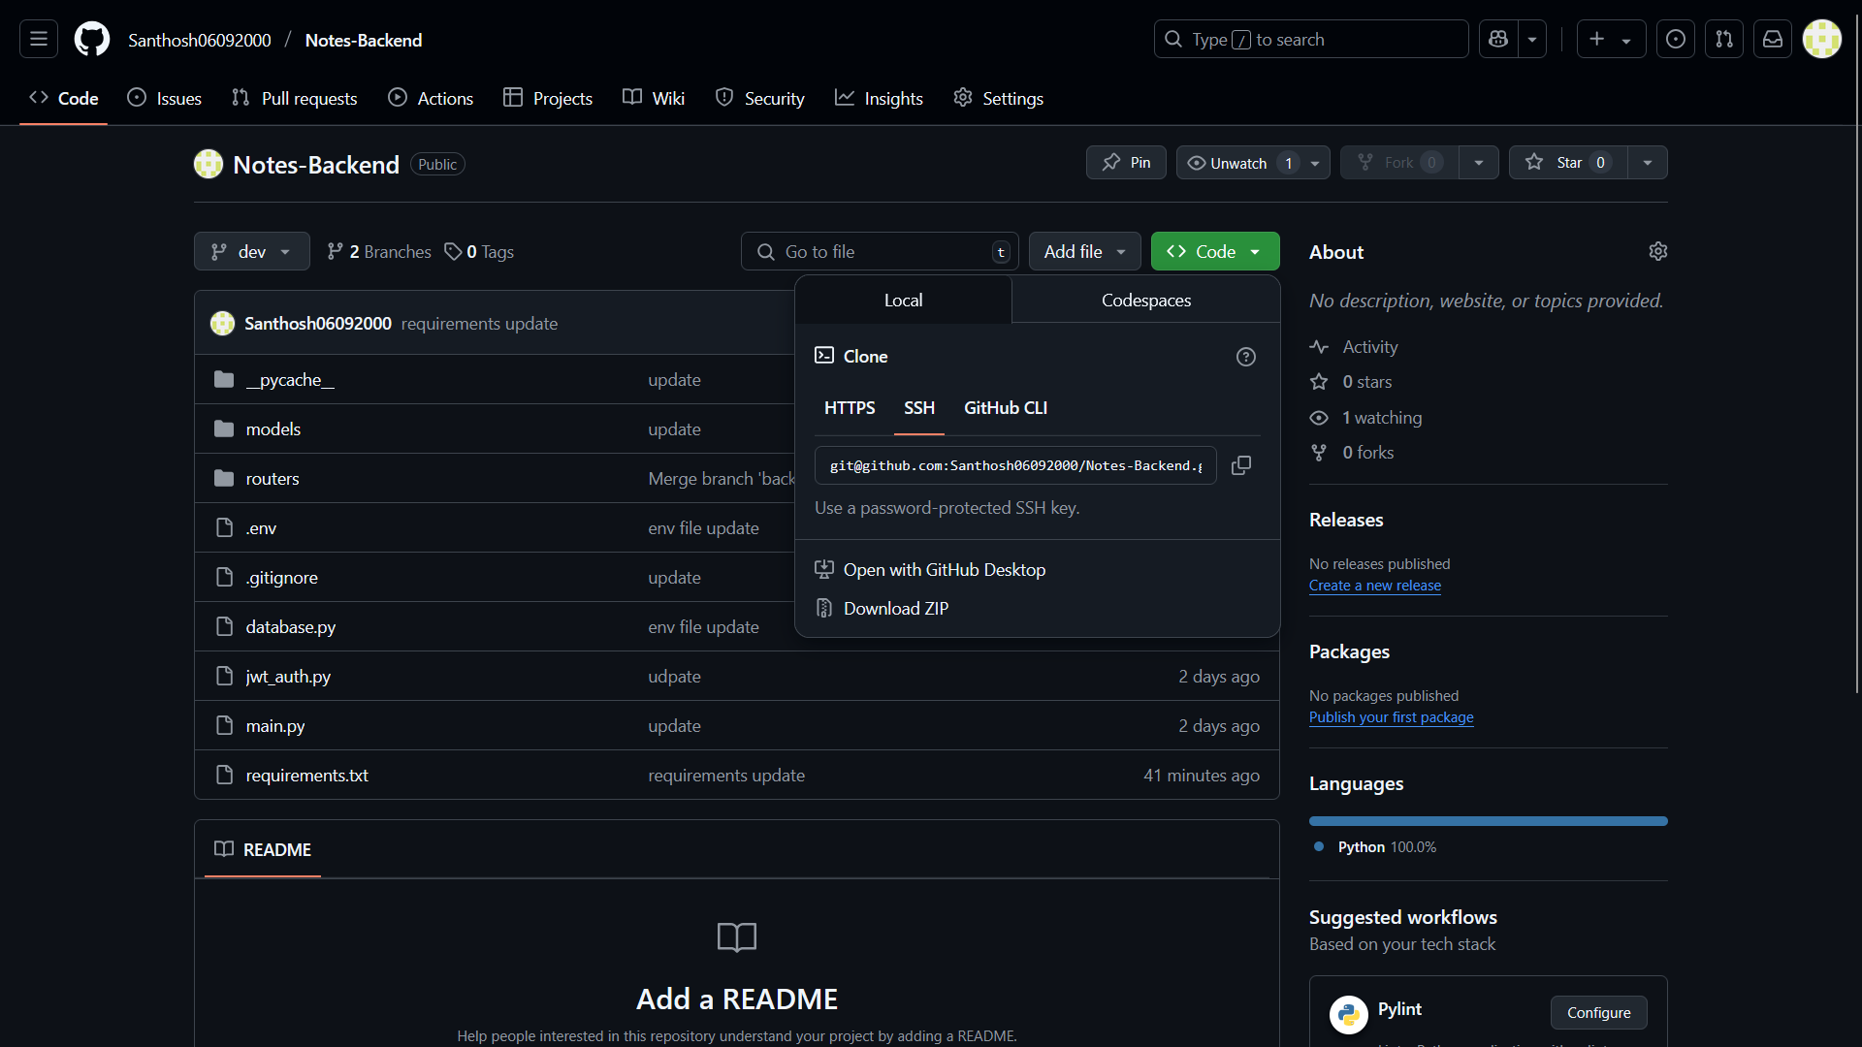
- Update the .env for the database URL
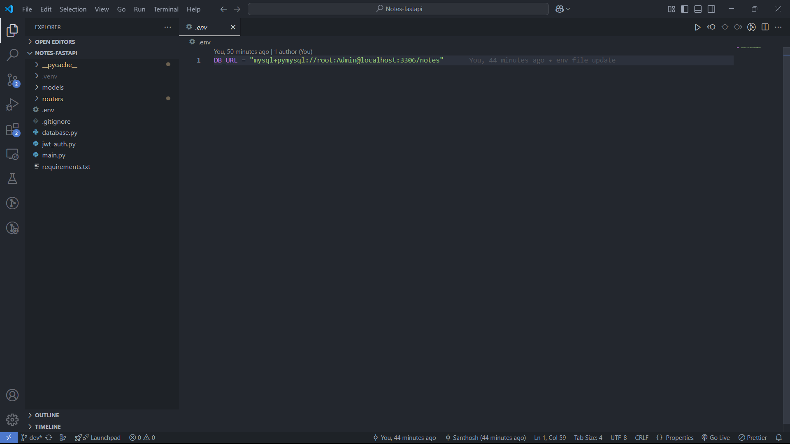
- Create venv with - python -m venv .venv
- Then install the Python necessary packages by - pip install -r requirements.txt
- Now run the app with - uvicorn main:app --reload
Check with swagger, the application runs smoothly by default port,
http://localhost:8000/docs#/
